Source codes

import numpy as np

import cv2

import matplotlib.pyplot as plt

from pylab import meshgrid, imshow, colorbar, show

# Image Setup

img = cv2.imread('/Users/louis/Documents/GitHub/Internship_Test_File/Car On Mountain Road.tif', cv2.IMREAD_COLOR)

img_gray = cv2.cvtColor(img, cv2.COLOR_BGR2GRAY)

def NormalizeData(data):

return (data - np.min(data)) / (np.max(data) - np.min(data))

img_gray = NormalizeData(img_gray)

img_gray = cv2.GaussianBlur(img_gray, (21, 21), 0)

# plot Gaussian Filter

sd = 2.5 # decrease standard error

def func(x, y):

first = (x * x + y * y - 2 * sd * sd) / (sd ** 4)

second = np.exp(-(x ** 2 + y ** 2) / (2 * sd ** 2))

return first * second

x = np.arange(-7, 8, 1) # width is sd*6 (+1) --> odd

y = np.arange(-7, 8, 1)

X, Y = meshgrid(x, y) # grid of point

Z = func(X, Y)

Z = Z - np.mean(Z)

im = imshow(Z, cmap='gray')

colorbar(im)

show()

resulting_image = cv2.filter2D(img_gray * 255, 1, Z)

# LoG Transform

print(type(resulting_image))

maximum = np.amax(resulting_image)

print('maximum', maximum)

threshold1 = 0.04

row, col = resulting_image.shape

s = (row, col)

zero = np.zeros(s)

zero4 = np.zeros(s)

for i in range(2, row - 1):

for j in range(2, col - 1):

if (resulting_image[i, j + 1] >= 0 and resulting_image[i, j - 1] < 0) or (

resulting_image[i, j - 1] >= 0 and resulting_image[i, j + 1] < 0):

zero[i, j] = 255

temp = np.abs(resulting_image[i, j + 1] - resulting_image[i, j - 1])

if temp > maximum * threshold1:

zero4[i, j] = 255

elif (resulting_image[i + 1, j] >= 0 and resulting_image[i - 1, j] < 0) or (

resulting_image[i - 1, j] >= 0 and resulting_image[i + 1, j] < 0):

zero[i, j] = 255

temp = np.abs(resulting_image[i + 1, j] - resulting_image[i - 1, j])

if temp > maximum * threshold1:

zero4[i, j] = 255

elif (resulting_image[i + 1, j + 1] >= 0 and resulting_image[i - 1, j - 1] < 0) or (

resulting_image[i - 1, j - 1] >= 0 and resulting_image[i + 1, j + 1] < 0):

zero[i, j] = 255

temp = np.abs(resulting_image[i + 1, j + 1] - resulting_image[i - 1, j - 1])

if temp > maximum * threshold1:

zero4[i, j] = 255

elif (resulting_image[i - 1, j + 1] >= 0 and resulting_image[i + 1, j - 1] < 0) or (

resulting_image[i + 1, j - 1] >= 0 and resulting_image[i - 1, j + 1] < 0):

zero[i, j] = 255

temp = np.abs(resulting_image[i - 1, j + 1] - resulting_image[i + 1, j - 1])

if temp > maximum * threshold1:

zero4[i, j] = 255

# img_gray2 = np.pad(img_gray2, pad_width=10, mode='constant', constant_values=0)

# print(img_gray2.shape)

# row,col=img_gray2.shape

# i=0

# j=0

# temp=img_gray2[i:i+21,j:j+21]

# out= np.dot(temp,Z)

# print(out)

# print(out.shape)

#

# for i in range(0,row-20):

# for j in range(0,col-20):

# temp=img_gray2[i:i+21,j:j+21]

# out= np.dot(temp,Z)

# img_gray2[i:i+21,j:j+21]=out

# new_img=img_laplacian * Z

# Hough Transform

plt.style.use('dark_background')

plt.figure(1)

zeroes = np.nonzero(zero4 != 0) # zeroes are the index of nonzero values of zero4

t = np.arange(-90, 90, 1)

for i in range(len(zeroes[0])): # len(zeroes[0])

plt.plot(t, zeroes[0][i] * np.cos(t * np.pi / 180) + zeroes[1][i] * np.sin(t * np.pi / 180), 'white', alpha=0.007)

plt.xlabel("Theta")

plt.ylabel("P (rho)")

plt.title("Hough Transformation")

plt.gca().invert_yaxis()

plt.show()

plt.figure(2)

for i in range(len(zeroes[0])):

if zeroes[0][i] >= 350 and zeroes[0][i] <= 450 and zeroes[1][i] >= 150 and zeroes[1][i] <= 270:

plt.plot(t, zeroes[0][i] * np.cos(t * np.pi / 180) + zeroes[1][i] * np.sin(t * np.pi / 180), 'white',

alpha=0.01)

plt.xlabel("Theta")

plt.ylabel("P (rho)")

plt.title("Hough Transformation (License Plate)")

plt.gca().invert_yaxis()

plt.show()

# License Plate Lines

theta = [-0.0689, -0.0460, 1.5695, 1.3108]

rho = [402.1, 376.5, 250, 255.5]

plt.figure(3)

for i in range(4):

temp = []

for j in range(len(zeroes[0])):

if zeroes[0][j] >= 380 and zeroes[0][j] <= 430 and zeroes[1][j] >= 150 and zeroes[1][j] <= 260:

if int(rho[i]) == int(zeroes[0][j] * np.cos(theta[i]) + zeroes[1][j] * np.sin(theta[i])):

if len(temp) == 0:

temp.append([zeroes[0][j], zeroes[1][j]])

else:

if zeroes[0][j] + zeroes[1][j] < temp[0][0] + temp[0][1]:

temp.insert(0, [zeroes[0][j], zeroes[1][j]])

if zeroes[0][j] + zeroes[1][j] > temp[len(temp) - 1][0] + temp[len(temp) - 1][1]:

temp.insert(len(temp), [zeroes[0][j], zeroes[1][j]])

yline = [temp[0][0], temp[len(temp) - 1][0]]

xline = [temp[0][1], temp[len(temp) - 1][1]]

plt.plot(xline, yline, 'red')

# sin = np.sin(theta[i])

# cos = np.cos(theta[i])

# b = 1 / cos * rho[i] # 1/sin*rho

# a = -sin / cos # -cos/sin

# y = np.arange(0, 1100, 1)

# plt.plot(y, a * y + b)

plt.xlim(0, 1100)

plt.ylim(700, 0)

plt.show()

# License Plate Lines on the picture

plt.figure(4)

plt.imshow(img)

for i in range(4):

temp = []

for j in range(len(zeroes[0])):

if zeroes[0][j] >= 380 and zeroes[0][j] <= 430 and zeroes[1][j] >= 150 and zeroes[1][j] <= 260:

if int(rho[i]) == int(zeroes[0][j] * np.cos(theta[i]) + zeroes[1][j] * np.sin(theta[i])):

if len(temp) == 0:

temp.append([zeroes[0][j], zeroes[1][j]])

else:

if zeroes[0][j] + zeroes[1][j] < temp[0][0] + temp[0][1]:

temp.insert(0, [zeroes[0][j], zeroes[1][j]])

if zeroes[0][j] + zeroes[1][j] > temp[len(temp) - 1][0] + temp[len(temp) - 1][1]:

temp.insert(len(temp), [zeroes[0][j], zeroes[1][j]])

yline = [temp[0][0], temp[len(temp) - 1][0]]

xline = [temp[0][1], temp[len(temp) - 1][1]]

plt.plot(xline, yline, 'red')

# for i in range(4):

# sin = np.sin(theta[i])

# cos = np.cos(theta[i])

# b = 1 / cos * rho[i] # 1/sin*rho

# a = -sin / cos # cos/sin

# y = np.arange(0, 1100, 1)

# plt.plot(y, a * y + b)

plt.xlim(0, 1100)

plt.ylim(700, 0)

plt.show()

# Houghlines= np.copy(zero4)

# Houghlinesback= np.copy(zero4)

# Houghlinesback=Houghlinesback.astype('float32')

# Houghlinesback = cv2.cvtColor(Houghlinesback, cv2.COLOR_GRAY2BGR)

# Houghlines=Houghlines.astype('uint8')

# print(Houghlines.dtype)

# # Houghlines= cv2.cvtColor(Houghlines, cv2.COLOR_BGR2GRAY)

# # Houghlines

# # lines = cv2.HoughLines(Houghlines, 1, np.pi / 180, 250) #returns an array of (rho, theta) values

# # print(lines.shape)

# # if lines is not None:

# # for i in range(len(lines)):

# # rho = lines[i][0][0]

# # theta = lines[i][0][1]

# # a = math.cos(theta)

# # b = math.sin(theta)

# # x0 = a * rho

# # y0 = b * rho

# # pt1 = (int(x0 + 1000 * (-b)), int(y0 + 1000 * (a)))

# # pt2 = (int(x0 - 1000 * (-b)), int(y0 - 1000 * (a)))

# # cv2.line(Houghlinesback, pt1, pt2, (0,0,255), 1, cv2.LINE_AA)

# # HoughLinesP

# linesP = cv2.HoughLinesP(Houghlines, 1, np.pi / 180, 5, None, 8, 10) #returns the extremes of the detected lines (x0,y0,x1,y1)

#

# if linesP is not None:

# for i in range(len(linesP)):

# l = linesP[i][0]

# cv2.line(Houghlinesback, (l[0], l[1]), (l[2], l[3]), (0, 0, 255), 2, cv2.LINE_AA)

#

# additional

# img_img = cv2.cvtColor(img, cv2.COLOR_BGR2GRAY)

# sobelX = cv2.Sobel(img_img, cv2.CV_64F, 1, 0)

# sobelY = cv2.Sobel(img_img, cv2.CV_64F, 0, 1)

# sobelX = np.uint8(np.absolute(sobelX))

# sobelY = np.uint8(np.absolute(sobelY))

# sobelCombined = cv2.bitwise_or(sobelX, sobelY)

#

#

#

# cv2.imshow('Output Image', new_img)

# cv2.imshow('Blured Image', blur)

cv2.imshow('Original', img)

cv2.imshow('Manual Blur', resulting_image)

cv2.imshow('Laplacian image', zero)

cv2.imshow('Laplacian image2', zero4)

# cv2.imshow('Houghlines Image', Houghlines)

# cv2.imshow('Houghlines Image', Houghlinesback)

# cv2.imshow("test",test)

# # cv2.imshow("Detected Lines (in red) - Standard Hough Line Transform", output)

# cv2.imshow("SobelX", sobelX)

# cv2.imshow("SobelY", sobelY)

# cv2.imshow("SobelCombined", sobelCombined)

cv2.waitKey(0)

cv2.destroyAllWindows()

Figures of the LoG image (10%), binary images by zero-crossings with

threshold of O and 4% of max(LoG)

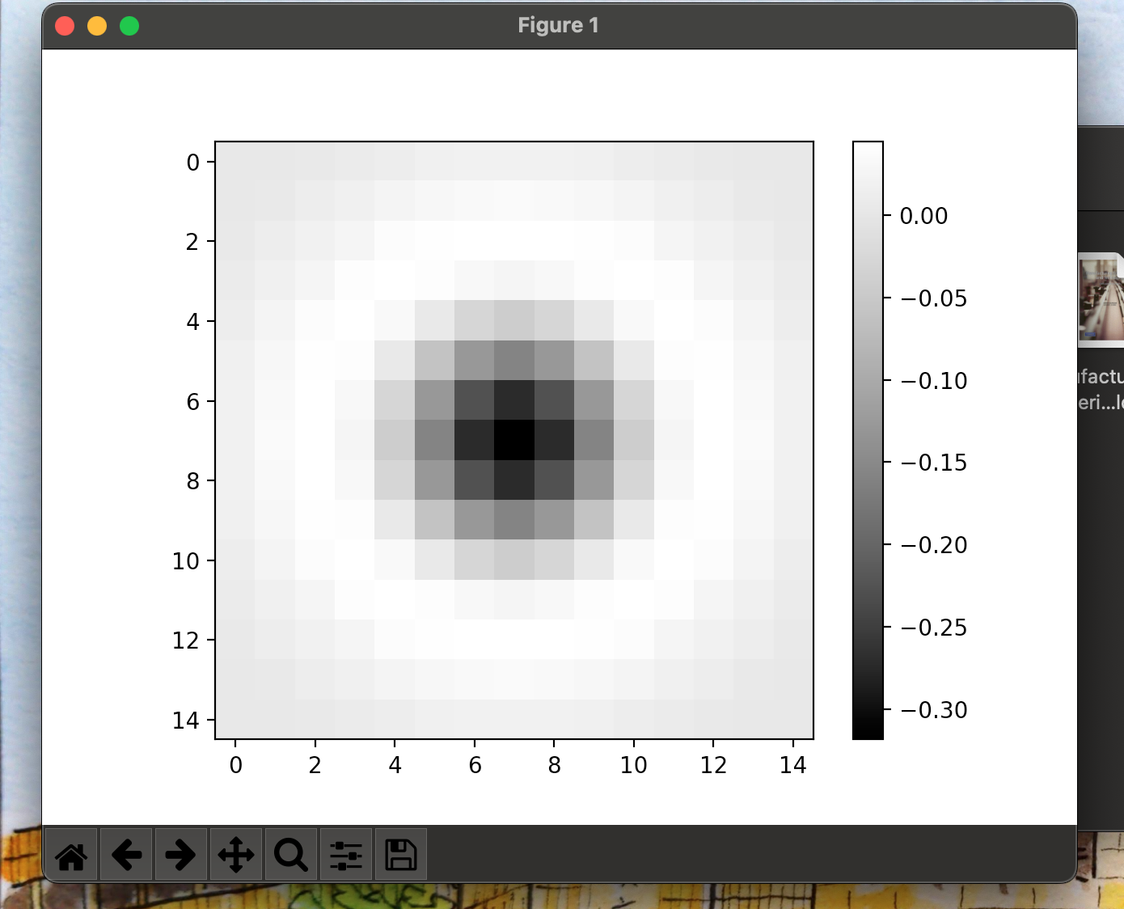

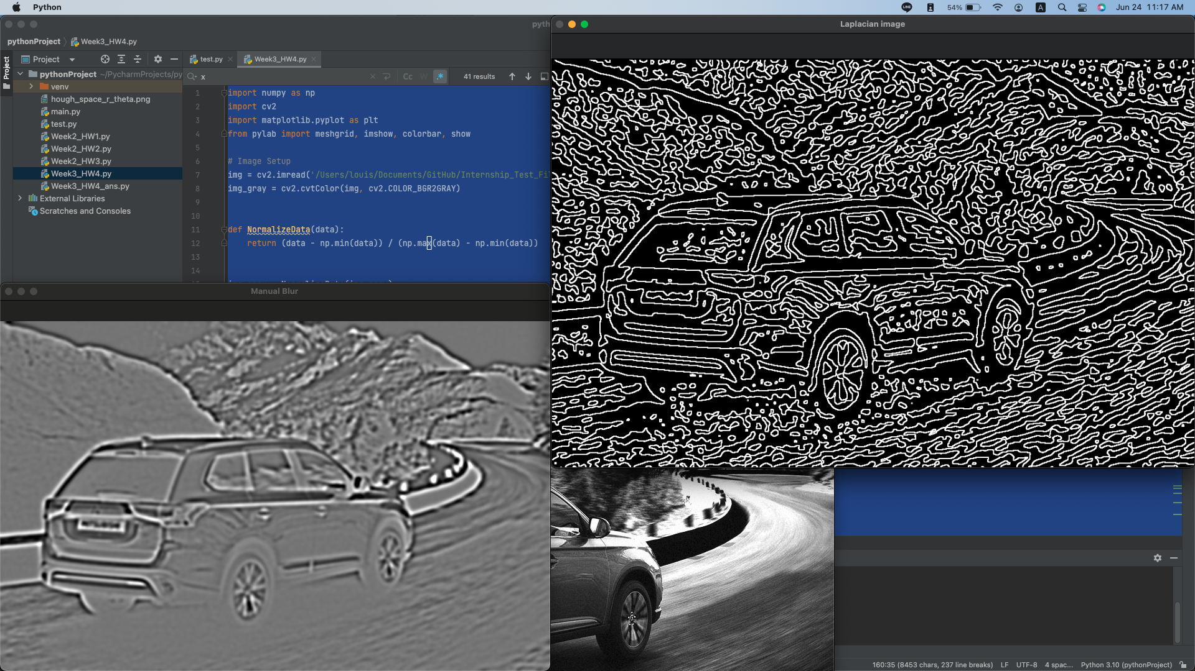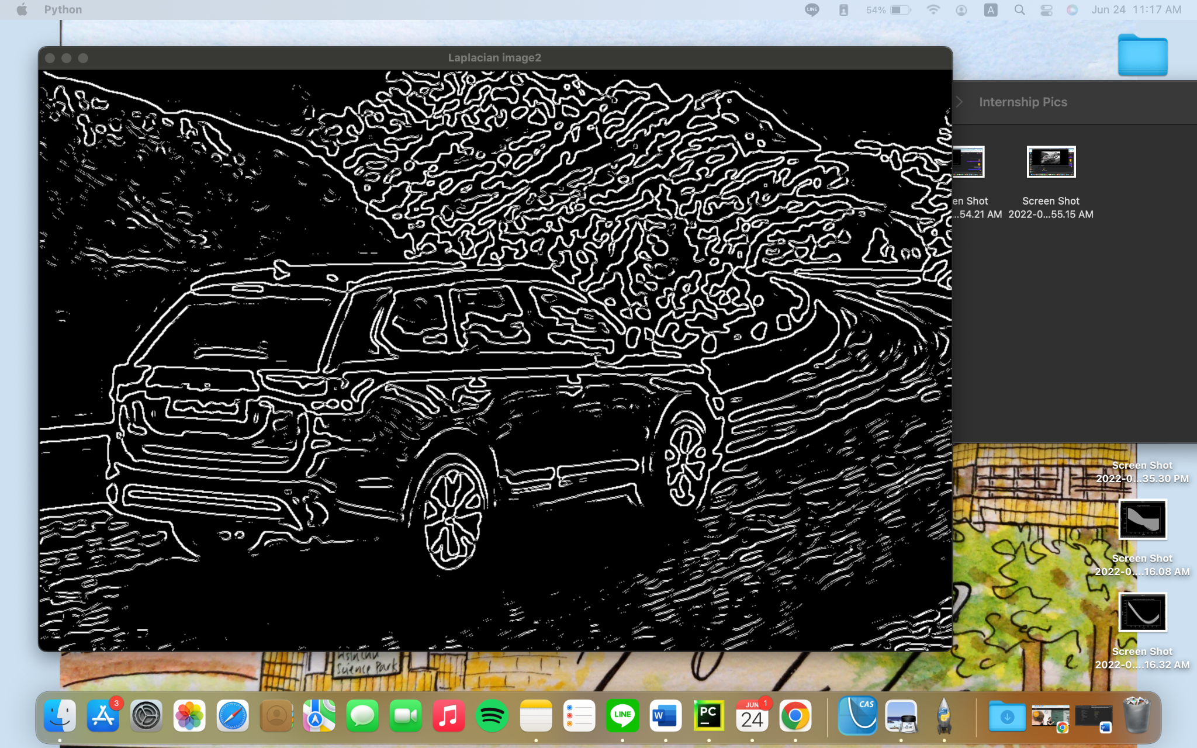

Figure of Hough parameter space, refer to Fig 10.31(c)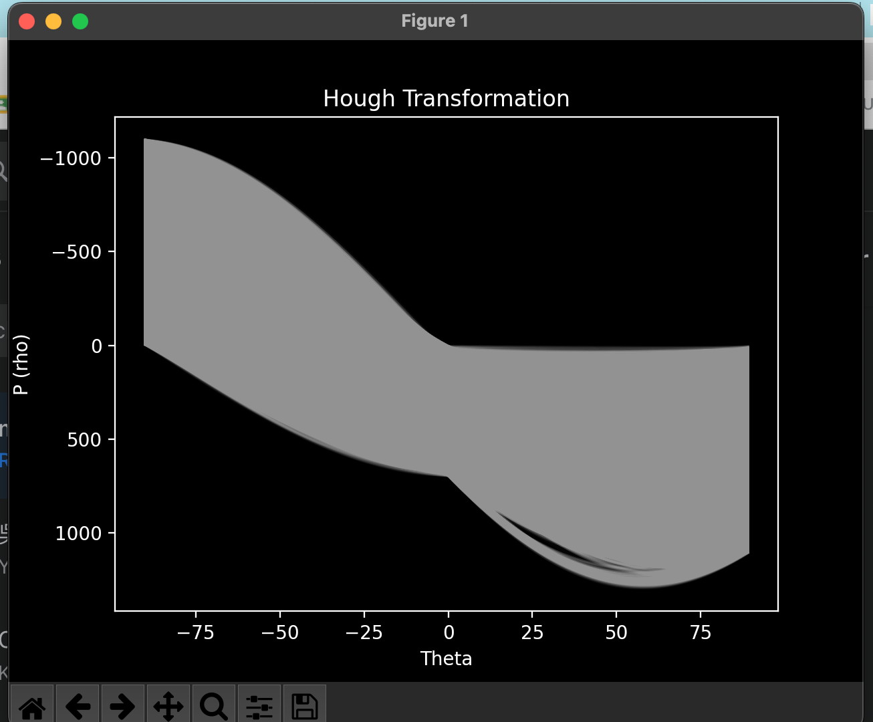

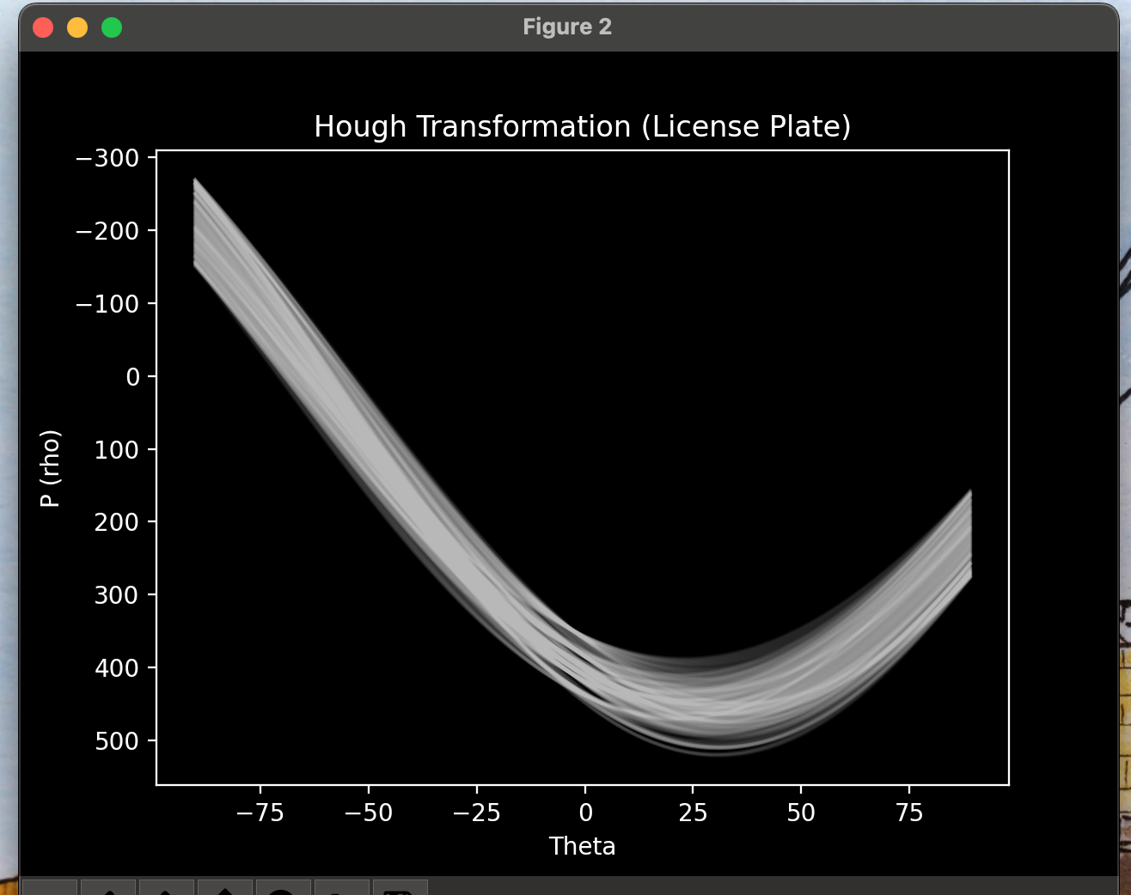

Figures of linked edges alone and overlapped on the original image,

refer to Fig 10.31(d), (e)

